**Unit 8 Assignment 1**

Laurence T. Burden

Purdue Global University

IN300: Programming for Data Analysis

John Brooks

June 15, 2021

**Python Code and Results**

**File A**

**File B**

**R Code and Results**

**File A**

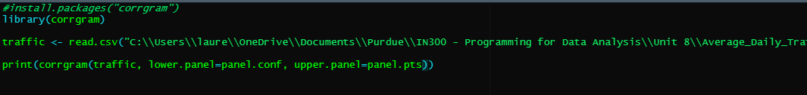

**File B**

**Java Code and Results**

**File A**

**File B**

**Compare and Contrast Languages**

The act of reading data and displaying it is different across each language. Java continues to find new ways to annoy me. The proper JDK for Java FX was not installed and Oracle will not let someone download it without an account. The amount of code to do the same thing as Python or R is orders of magnitude larger.

R used significantly less lines of code than Python this time around. This appears to be because R will read the column names into the data frame by default. Python required that each column name be added to an array first. R’s libraries were easy to use as well. I preferred using R for this project.